Step 1: Begin the Setup
- Go to https://myaccount.microsoft.com and sign in with your CNU account.
- When prompted for additional security information, click Next.
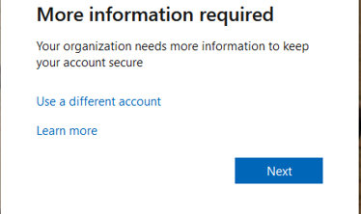

Step 2: Download the Microsoft Authenticator App
You will be directed to a page asking you to download the Microsoft Authenticator app.
- Click Download now, or
- Use the QR code displayed on the screen.
Choose the correct app store for your device:
- Android: Google Play Store
- iPhone: Apple App Store
If you are already on your mobile device, your screen will look like the example shown.
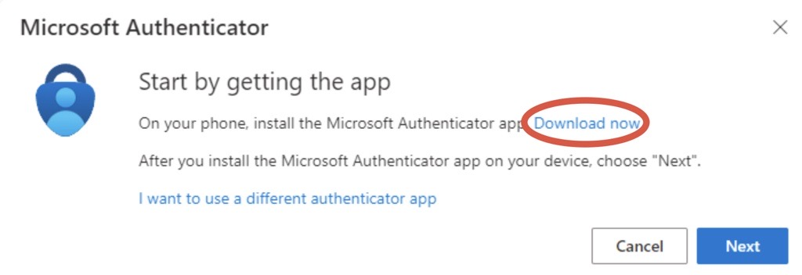
If you are on your mobile device, the screen will look like this:
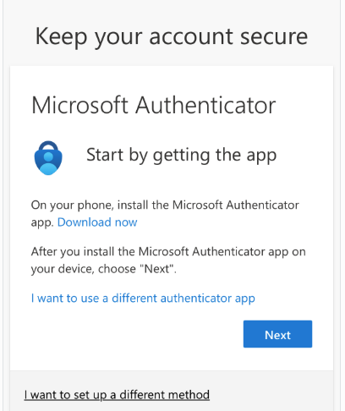

Step 3: Install the Microsoft Authenticator App
After clicking Download now, install the Microsoft Authenticator app using the provided link or QR code.
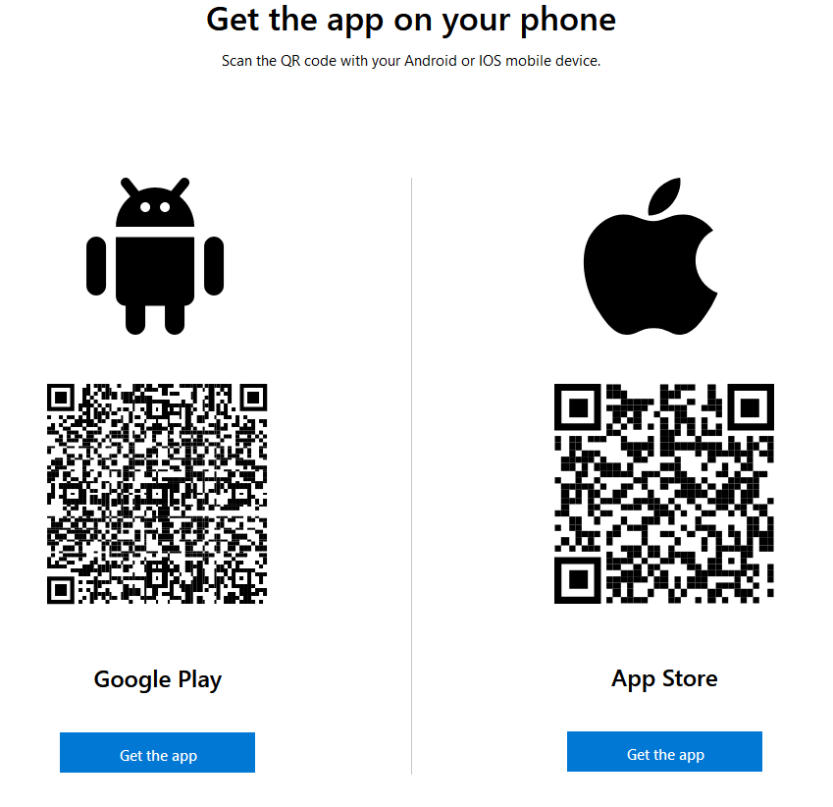

Step 4: Continue the Setup
After the app is installed, click Next on your computer or mobile device to continue.
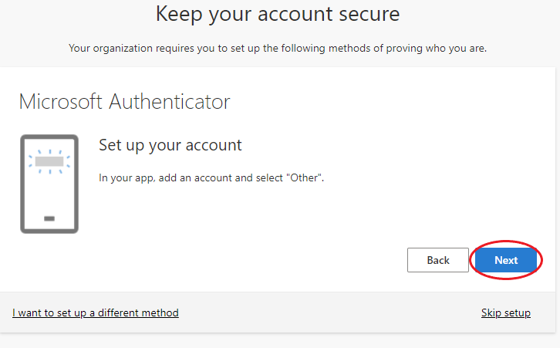

Step 5: Pair Your Account with the App
If you are setting this up on your mobile device:
- Tap the link on the screen to pair your account with the app.
If you are setting this up on a computer (recommended):
- Open the Microsoft Authenticator app on your phone.
- Tap the + (plus) icon.
- Select Work or school accounts.
- Tap Scan QR code.
- Use the app to scan the QR code displayed on your computer screen.
Important:
- Make sure you scan the QR code using the Microsoft Authenticator app, not your phone’s camera app.
- Ensure the app has permission to access your camera.
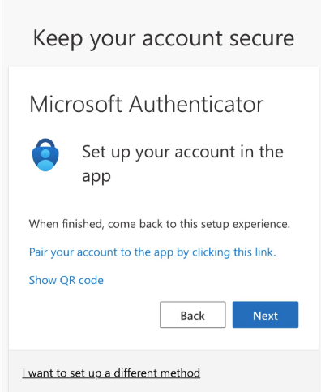

If you are setting this up on a computer, the easiest way to pair your device is to scan the QR code with the Authenticator app:
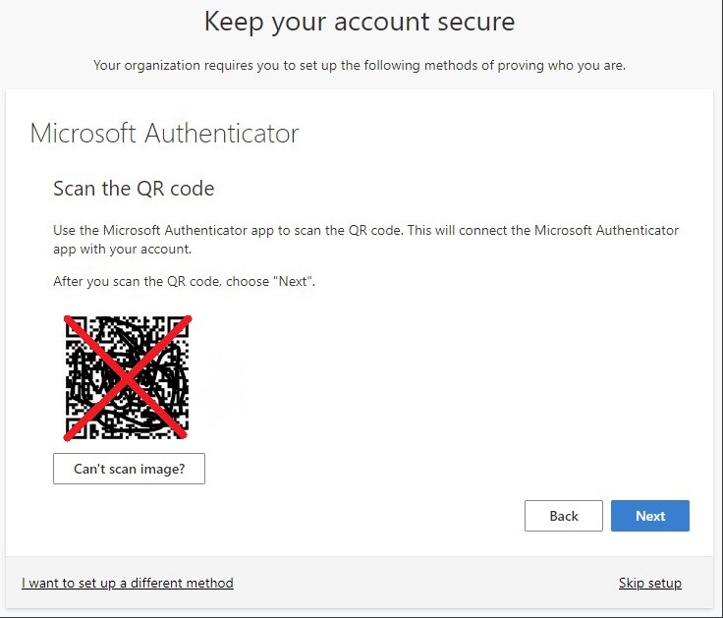

On the Authenticator app, tap the plus button.
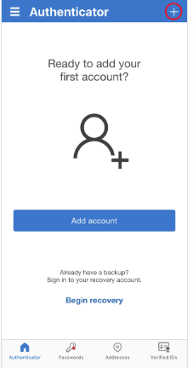

Tap, "Work or school account," then "Scan QR code"
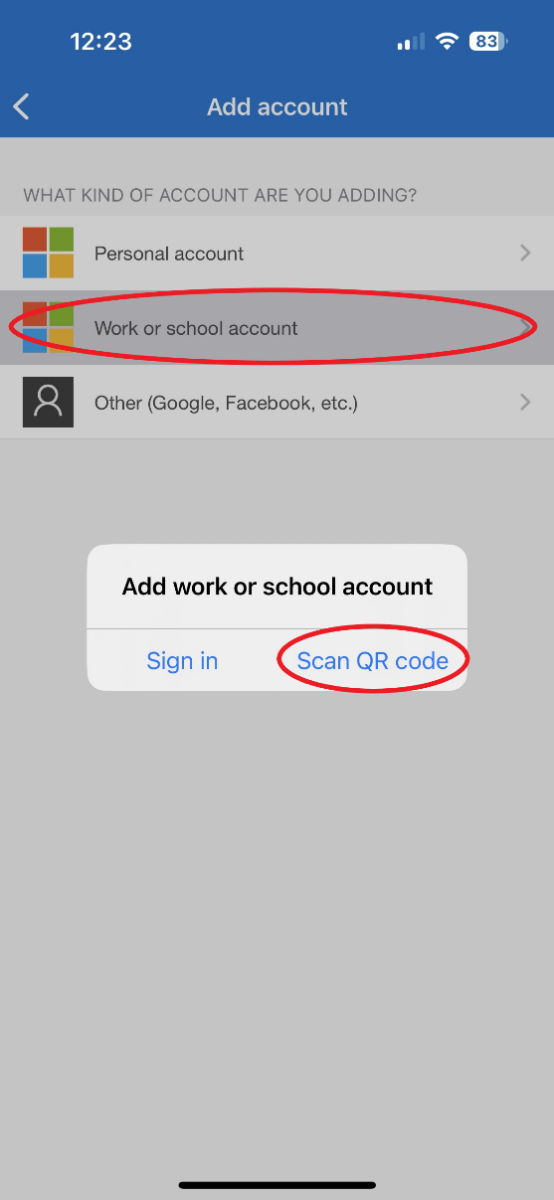

Scan the QR Code. Make sure you scan the QR code with the Microsoft Authenticator App, not just using the device's camera app.

Note: Allow the app to access your Camera if requested.
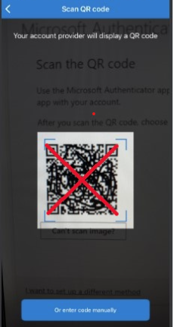
Step 6: Send a Test Notification
Once your account is successfully paired, click Next to send a test notification to the Microsoft Authenticator app.

Step 7: Approve the Test Notification
On your phone, approve the sign-in request in the Microsoft Authenticator app by entering the two-digit number shown on the screen.

Click Done to finish.
Your Microsoft Authenticator app is now set up and ready to use for secure sign-ins.

